Dalton Murray

Systems Analysis and Design

INT 6123 – Systems Analysis and Design

Dr. Andrew Makar

September 10, 2023

**IA #3 Spring Breaks R Us**

**Question 1 – Using the event decomposition technique for each event you identify in the description here, name the event, state the type of event, and name the resulting use case. Draw a use case diagram for these use cases.**

In order to use the event decomposition technique, we must identify all business events which information system responds to, determine its type of event such as if it is an external, temporal, or state event, and then identify and name the use case which the system requires (Satzinger et al., 2016. p. 74 - 80). Breaking down the new description of SBRU in this chapter I have identified a few different business events and their resulting use cases. In order to format my responses properly I will break them down one by one in a way which I find to be a logical order of events.

With the booking subsystem

* 1. Business event: Students want to browse through different resorts
  2. Type of event: External – This happens outside of the system, as the students want to browse through different resorts not as a result of the system and was initiated by the students. It is also possible for this to be seen as a temporal event because the students are looking for resorts because it is spring break.
  3. Resulting use case: Because the student wants to browse for different resorts, we will then show them different resorts information
  4. Business event: After students browse through different resorts they will then look through different packages which the resort offers and different types of deals and suites there are
  5. Type of event: External – The students have chosen a resort and are looking at its different packages, this is happening because of them picking a resort to find more information about
  6. Resulting use case: Show more information about the type of packages, deals, discounts, and suites for the resort they are looking at
  7. Business event: The college students now book the reservation
  8. Type of event: External – The students have found a resort and the packages, deals, and suites which they want, they now book the reservation
  9. Resulting use case: The internal systems process the reservation and the students now have a confirmation that they booked the reservation
  10. Business event: A group of students have booked a reservation
  11. Type of event: Internal – This is at the request of them booking the reservation and the processing which needs to be handled internally such as sending the information to the resort and getting back the confirmation or failure to confirm which then gets sent to the students
  12. Resulting use case: The confirmation or failure to book message gets sent to the students
  13. Business event: Students need to be added or dropped to the group and need to change size/different room
  14. Type of event: External – The systems do not influence this and the students do
  15. Resulting use case: We process with the resort the change in the group booking to add or decrease the amount of people and change to their requested room
  16. Business event: Send out final payment requirement notices
  17. Type of event: Temporal – This is a result of time passing and the students having a booked reservation
  18. Resulting use case: We handle internal processing and send out the payment notices to the group
  19. Business event: Students now pay the booking payments
  20. Type of event: External – They handle this externally which is then handled by our internal systems and their banks
  21. Resulting use case: We receive their money
  22. Business event: Students cancel booking
  23. Type of event: External – This has happened without the influence of our systems and is done by a result of their actions
  24. Resulting use case: We process the cancellation and handle the processing with the resort
  25. Business event: Students check their resort details
  26. Type of event: External – They are checking the resort details as a result of their own wants
  27. Resulting use case: We show them the resort details
  28. Business event: Students check in at resort
  29. Type of event: External – They have checked in by their own actions and is not a result of our internal processing. Although, this could also be seen as temporal as it happens due to time after their booking but by their own actions.
  30. Resulting use case: The resort confirms with us their check in
  31. Business event: The students check out
  32. Type of event: External – Temporal – They check out due to their own actions but this could also be seen as it will happen naturally with time due to their actions of scheduling a set amount of time for the booking.

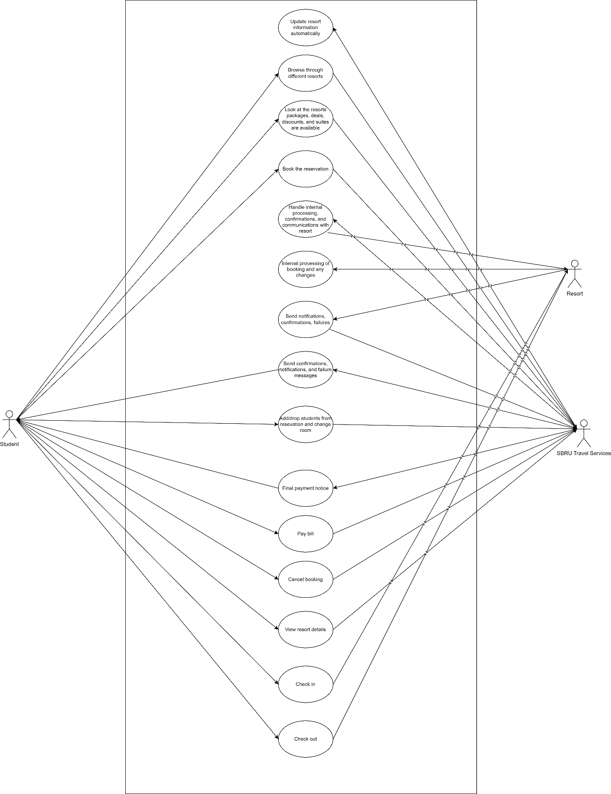

**Question 2 – Consider the new Social Networking subsystem that SBRU is researching that was described in Chapter 2. Think in terms of the user goal technique to identify as many use cases as you can think of that you would like to have in the system. SBRU is guessing you might want to join, send messages, and so forth, but there must be many interesting and useful things the system could do before, during, and after the trip. Draw a use case diagram for these use cases.**

Some use cases for the social networking subsystem which I can think of for SBRU are as follows: creating an account, deleting an account, sending messages, setting filters/preferences such as activities you like or distance from your position, randomized searching for another person or group of people, creating group chats, looking up other people on the network, have a sort of wall/personal feed where you can upload pictures and videos of places you’ve traveled to and things you’ve done, being able to voice call and video call in the network, post comments on other people’s walls/profiles, have safety/security settings so you can block and report people, have some sort of verification system so you know you’re talking with who you think you are, be able to change the language of the app

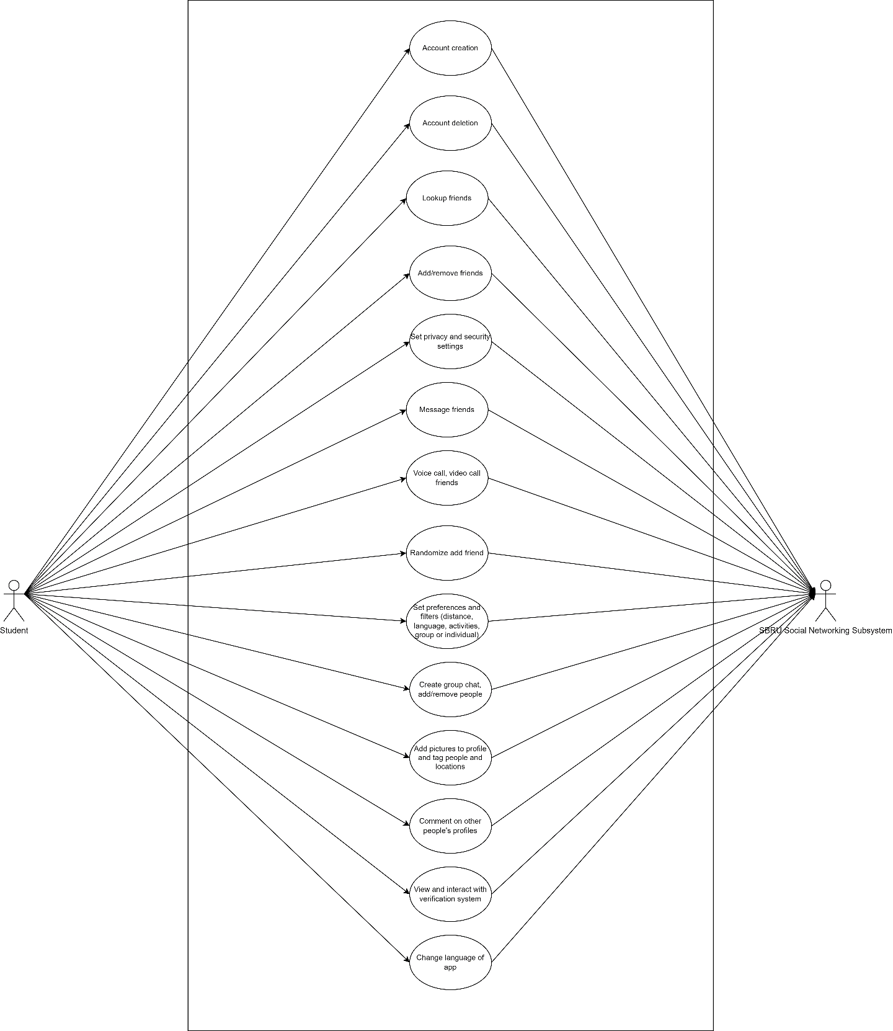

**References**

Satzinger, J. W., Jackson, R. B., & Burd, S. D. (2016). Systems analysis and design in a Changing World (7e ed.). Cengage Learning.

I have neither given nor received unauthorized aid in completing this work, nor have I presented someone else's work as my own.

*Dalton Murray*